

PRODUCT SPEC SHEET

JUMBO ELLIPSE TISSUE DISPENSER

KHP PART No: TSD JMB ELP

DESCRIPTION

- Accepts range of readily available jumbo toilet rolls up to ∅280mm max.
- Replaceable front insert.
- Roll held on braked mandrel, giving smooth controlled operation
- Accepts core diameters 56mm – 62mm
- Two cutting knives provide efficient paper cutting from either side.
- Dispenser can be sited on left or right hand side of cubical.
- Hinged cover and locking from the top of the dispenser for security.

DIMENSIONS

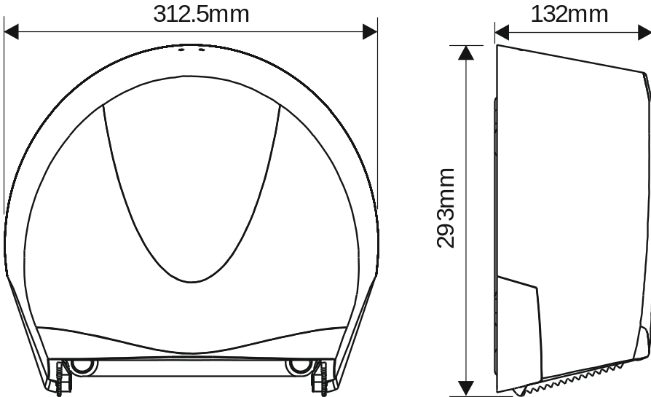

MATERIALS

Constructed from ABS and other engineering thermoplastics. Dispenser can be recycled or disposed of in accordance with local regulations.

PACKING

Individual units packed in polybags with outer sleeve around unit.
Individual weight: 1.05Kgs
6 units packed into carton: 1000mm x 360mm x 325mm
Total weight: 7.7Kgs



