

PRODUCT SPECIFICATION SHEET

TEKNA ELLIPSE MECHANICAL RETRACTABLE CABINET

KHP Part No: CAB TEK ELP

DESCRIPTION

- Fully retractable standard width cotton towel cabinet.
- Designed to be used with 40M long standard width towels, up to maximum width of 270mm.
- Replaceable front insert.
- Clean towel stored above dirty towel in transparent ABS bin for total separation between clean and dirty towel.
- Stop mechanism to control towel consumption.
- Mechanism can be easily removed without tools.
- Self supporting cover with snap shut action.
- Transparent side windows for easy towel level indication.
- Left/Right hand lock. Lock uses key common with other products in the range.

DIMENSIONS

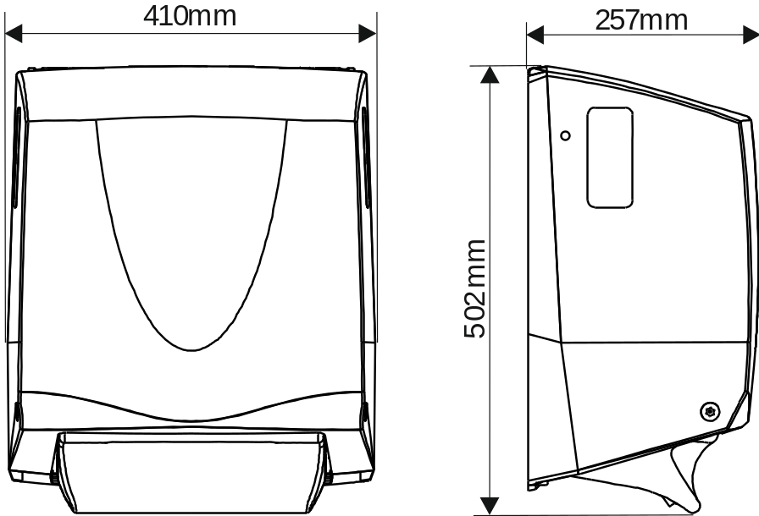

MATERIALS

Constructed from ABS, other engineering thermoplastics and metal fabrication where necessary for strength and reliability.
Cabinet can be recycled or disposed of in accordance with local regulations.

PACKING
A single cabinet is packed into a double wall box with key and instruction sheet.
Box dimensions: 50cm x 43cm x 26cm
Individual Weight: 8.4 kg.

